UNIT TEST
Unit Test Examination
Faculty: BE
Subject: Basic Electrical Engineering
Semester: First Full Marks: 70
Time: 2:00 hrs Pass Marks: 35

Attempt all questions:

- a. Differentiate between Ideal current and Ideal Voltage source. [7]

b. Find the equivalent resistance across point A and B. [8]
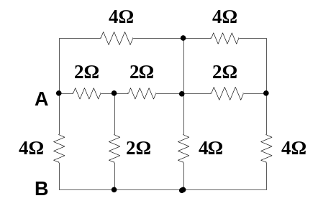
- a. Find the current through 2Ω resistor using superposition theorem. [7]
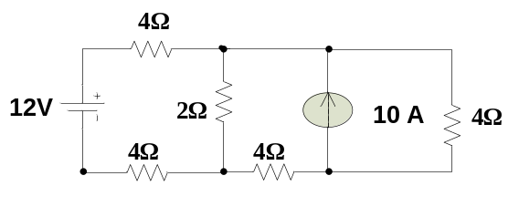

b. Find the value of loop currents and the value of Vx in the circuit below. [8]
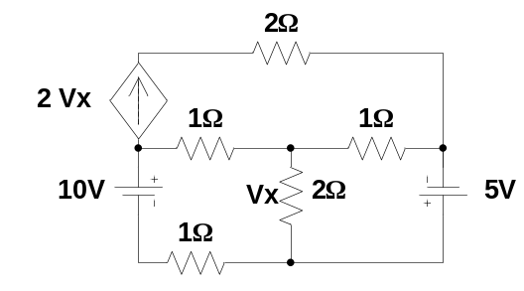
- a. Find the Value of R_{L} so that maximum power is transferred across the load. Also calculate the value of its Maximum power. [8]

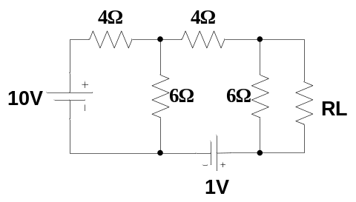
b. Use Nodal analysis to determine the current in the 5 Ω resistor in the circuit below. [7]
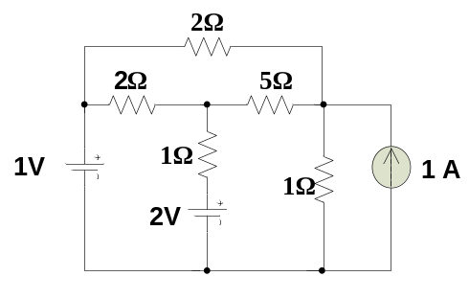

- a. Describe the Generation of Alternating Emf. [7]

b. Calculate Average value, critical value, form factor and the crest factor of the following waveform. [8]
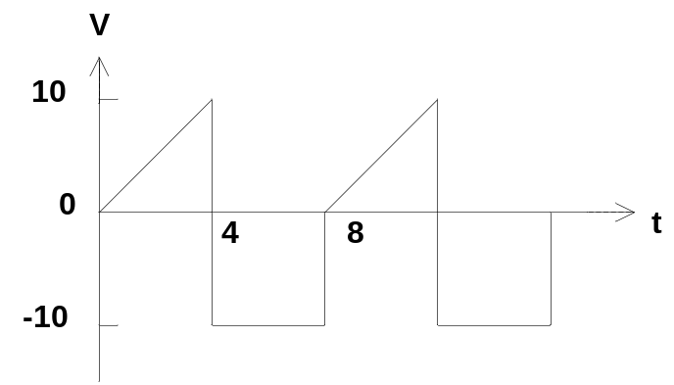

- Write Short Notes on (any two) [5*2=10]
- Norton’s theorem
- Effective and Average Value.
- Supernode

